# 

# User Manual

Author: Zhen Li

GNSS Research Center, Wuhan University,

No. 129 Luoyu Road, 430079, Wuhan China



**Contents**

1.Overview 1

1.1. User Notice 1

1.2. Main Features 1

1.3. Contact Details 3

2. Requirement 4

3. Quick Start 6

3.1. Installation 6

3.2. Data Processing 6

3.3. Script for Plotting 7

4. Configuration File 9

5. Dataset 13

5.1. KPL Dataset 13

5.2. Huawei P40 Dataset 16

5.3. Huawei Mate20 Dataset 20

6. Mathematical Model 23

6.1. Graph optimization 23

6.2. SPP using graph optimization 24

6.3. RP using graph optimization 26

6.4. Estimation of Velocity 28

Acknowledgement 30

Reference 30

# Revision

|  |  |  |
| --- | --- | --- |
| **Date** | **Version** | **Note** |
| 2022/08/25 | V1.0 | New |
|  |  |  |
|  |  |  |
|  |  |  |
|  |  |  |
|  |  |  |

# Overview

## User Notice

POSGO (POSition based on Graph Optimization) is a multi-frequency and multi-GNSS pseudorange data processing software program based on GO (Graph optimization). This software is written in the C/C++ programming language (version 11 or higher) and is recommended to be compiled and run in the Linux environment for execution efficiency.

POSGO is completely open and does not use any protective module. We open source it to provide a useful tool for positioning based on GO with GNSS, and can be used as a basic platform for multi-sensor fusion. In addition, Shengyi Xu of Wuhan University provided the plotting script for analyzing the results. The software is financially supported by the National Natural Science Foundation of China (41974035, 42030109), and Yong Elite Scientists Sponsorship Program by China Association of Science and Technology (2018QNRC001).

The source code of POSGO can be found on the GPS Toolbox Web at <https://geodesy.noaa.gov/gps-toolbox/>, or the Li’s GitHub at <https://github.com/lizhengnss/POSGO>. The latest updates and FAQs can be found on GitHub. This package is copyrighted under the GNU General Public License (version 3)

## Main Features

The main features of the software are listed in the following:

* Single-Point Positioning (SPP) and Relative Positioning (RP) positioning based on GO
* Support several loss functions for robust estimation in GO
* Support multi-constellation data processing
* Support single-frequency and dual-frequency ionospheric-free SPP
* Support multi-frequency RP

In addition, to ensure the completeness of the software, POSGO also supports SPP based on least square (LSQ) and RP based on the extended Kalman filter (EKF). The overall framework of POSGO is shown in **Fig. 1**.



**Fig. 1** The general framework of POSGO software. The software supports the SPP (red part) and DDP (green part) positioning modes, as well as the output of the debug log. GO and LSQ are supported in SPP, whereas GO and EKF are supported in DDP. (GO: graph optimization, LSQ: least square, EKF: extended Kalman filter)

First, POSGO needs to obtain the configuration from the file. Then, the GNSS product, e.g., broadcast ephemeris and global ionosphere model (GIM), will be loaded according to the setting. Meanwhile, the GNSS observations will also be read epoch wise. After that, positioning based on SPP or RP will be performed according to the user’s choice. In the SPP mode, satellite position will be calculated first, and then estimation based on LSQ or GO will be carried out. If GO is selected, velocity estimation will be performed in advance to construct the velocity factor. In RP mode, it is first necessary to match the reference and rover observations. After that, SPP will be performed to provide an initial position, and then estimation based on EKF or GO will be performed. Velocity estimation is also needed if the user selects the GO. Finally, the solution will be exported according to the setting. Debug information can also be outputted if the debug mode is selected, which is convenient for users to debug the software.

## Contact Details

You can contact us by sending an email or leaving a message on our website to submit bugs and comments.

**E-mail:** sdkjlizhen@foxmail.com

**website:** https://github.com/lizhengnss

# Requirement

POSGO is recommended to be compiled and run in the Linux environment for execution efficiency. We tested in the environment as the table below, the test results are consistent with the references and this document.

**Note:** You can also try other Linux distributions or even windows system, let us know if you have any problems.

Two open-source math libraries are used. These are the matrix operation library Eigen (<https://eigen.tuxfamily.org>) and the Ceres of Google used to solve the optimization problem (<http://www.ceres-solver.org/>). Make sure these two libraries are installed correctly before installing POSGO. You can refer to the following steps:

**Step1:** download Ceres

<http://ceres-solver.org/ceres-solver-2.1.0.tar.gz>

**Step2:** Install CMake

sudo apt-get install cmake

**Step3:** Install google-glog + gflags

sudo apt-get install libgoogle-glog-dev

**Step4:** Use ATLAS for BLAS & LAPACK

sudo apt-get install libatlas-base-dev

**Step5:** Install Eigen3

sudo apt-get install libeigen3-dev

**Step6:** Make Ceres-solver

tar zxf ceres-solver-2.1.0.tar.gz

mkdir ./ceres-solver-2.1.0/ceres-bin

cd ./ceres-solver-2.1.0/ceres-bin

cmake ..

sudo make -j4

sudo make test

sudo make install

|  |  |  |  |
| --- | --- | --- | --- |
| **System** | **Eigen** | **Ceres** | **Result** |
| Ubuntu 18.04 X64 | 3.3.4 | 2.0.0 | √ |
| Ubuntu 18.04 X64 | 3.3.4 | 2.1.0 | √ |
| Ubuntu 18.04 X64 | 3.3.5 | 2.1.0 | √ |
| Ubuntu 18.04 X64 | 3.3.7 | 2.1.0 | √ |
| Ubuntu 18.04 X64 | 3.3.9 | 2.1.0 | √ |
| Ubuntu 20.04 X64 | 3.3.7 | 2.1.0 | √ |
| Ubuntu 20.04 X64 | 3.3.9 | 2.1.0 | √ |
| Ubuntu 22.04 X64 | 3.4.0 | 2.1.0 | √ |

# Quick Start

## Installation

After download the source code of POSGO and make sure you have installed some necessary programs listed above in advance, you can refer to the following steps to compile the software:

**Step1:** mkdir build

**Step2:** cd build

**Step3:** cmake .. -DCMAKE_BUILD_TYPE=Release

**Step4:** make -j4

**Step5:** Check if the compilation was successful

./POSGO

If the following message is displayed, the installation is successful!

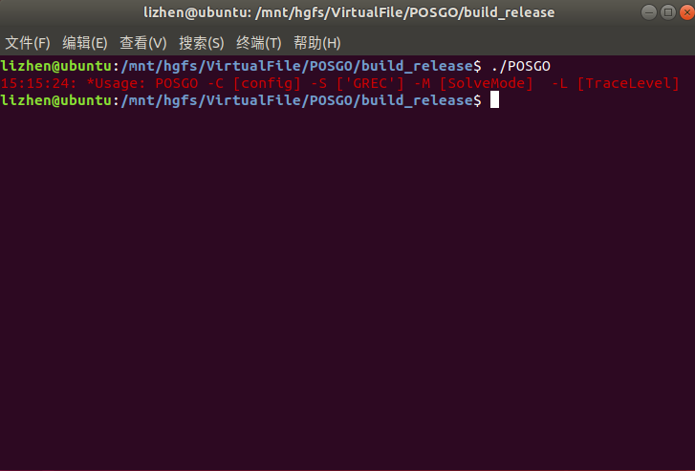

## Data Processing

program arguments need to be given in the following format when the software is running:

POSGO -C [config] -S [GREC] -M [ProcessMode] -L [TraceLevel]

The detailed description of the program parameters is as follows

|  |  |  |
| --- | --- | --- |
| Arguments | Mark | Value |
| -C | Configuration file path | String |
| -S | Selected GNSS | String  G stands for GPS;  C stands for BDS;  R stands for GLONASS;  E stands for Galileo;  Such as G, GC, GCE and GCER |
| -M | Processing mode | String  SPP:  single-point positioning processing mode;  RTK: double-differenced positioning processing mode; |
| -L | Debug level  The debug information will export to “DebugFile” according to configuration file | Int, 0-5  0. do not export  1. Error information;  2. Info information;  3. Warning information;  4. Debug information;  5. Export information; |

The program parameters of SPP GOLD in paper are as follows:

POSGO -C YOURPATH/conf/spp_kpl_gold.ini -S GREC -M SPP -L 1

The program parameters of RP GOLD in paper are as follows:

POSGO -C YOURPATH/conf/rp_kpl_gold.ini -S GREC -M RTK -L 1

## Script for Plotting

Shengyi Xu of Wuhan University provides python scripts for result analysis and plotting for this software. You can use this script for fundamental analysis and drawing. Results analysis of dynamic data using Analyze.py, the program parameters are as follows:

Analyze.py [result_file] [ref_file]

|  |  |  |
| --- | --- | --- |
| Arguments | Mark | Value |
| [result_file] | POSGO result file path | String |
| [ref_file] | Reference file path | String  We provide the function that reads the Waypoint and GINS reference file, users can make changes in the script according to their needs. For KPL dataset, the reference values are in the waypoint format, and Huawei P40 dateset is GINS format. The format can refer to the sample file, and users can also customize it according to their own needs. |

Static data using AnalyzeStatic.py, the program parameters are as follows:

AnalyzeStatic.py [result_file] [type] [b/x] [l/y] [h/z]

|  |  |  |
| --- | --- | --- |
| Arguments | Mark | Value |
| [result_file] | POSGO result file path | String |
| [type] | Type of coordinate, blh or xyz | String |
| [b/x] | Latitude or x in ECEF-XYZ | Double |
| [l/y] | longitude or y in ECEF-XYZ | Double |
| [h/z] | Height or z in ECEF-XYZ | Double |

# Configuration File

Properly configuring the options in the configuration file is a crucial step to running POSGO successfully. The following describe each option in more detail:

|  |  |  |
| --- | --- | --- |
| Options | Descriptions | Notes |
| NumFreq | The number of used frequencies | SPP mode only support 1 and 2(IF), RP mode support any number of frequencies |
| Start_End_Time | start and end time of data processing, the format is as follows:  yyyy/mm/dd hh:mm:ss - yyyy/mm/dd hh:mm:ss  If not configured, all data will be processed by default | yyyy: year;  mm:month;  dd:day;  hh:hour;  mm:minute;  ss:second |
| GPS_Freq | specified the used frequencies for GPS, support L1, L2 and L5 | Use "+" to concatenate frequency identifiers, such as L1+L2 |
| BD2_Freq | specified the used frequencies for BDS-2, support B1I, B2I and B3I |  |
| BD3_Freq | specified the used frequencies for BDS-3, support B1I, B1C, B2a, B2b, B2ab and B3I |  |
| GLO_Freq | specified the used frequencies for GLONASS, support G1 and G2 |  |
| GAL_Freq | specified the used frequencies for Galileo, support E1, E5a, E5b, E5ab and E6 |  |
| BdsOption | BDS processing strategy  1. bd2, only use BDS-2;  2. bd3, only use BDS-3;  3. bd23, use both BDS-2 and BDS-3, and treat them as a system for data processing;  4. bd2-3, use both BDS-2 and BDS-3, but treat them as different systems for data processing |  |
| SolverMode | Estimator type  1. lsq, least squares;  2. ekf, Extended Kalman Filter;  3. go, graph optimization; | lsq only support SPP mode and ekf only support RP mode |
| RobustMode | Robust kernel function type  1. off, do not use robust kernel function;  2. IGG3, use Institute of Geodesy and Geophysics;  3.huber, use huber kernel function; |  |
| LossFunction | Loss function in GO algorithm  1. off; 2. huber; 3. cauchy; 4. arctan; 5. softone; 6. tolerant | In GNSS data processing, huber or Cauchy are recommended |
| LossFunValue | on-negative scalar, you can get more detailed information from <http://ceres-solver.org/> |  |
| SlideWindowSize | Sliding window size in GO algorithm |  |
| Ionospheric | Ionosphere correction  1. off, do not correct ionosphere delay;  2. brdc, use broadcast model;  3. IF, ionosphere-free combination;  4. GIM, use Global Ionosphere Model | IF only support SPP mode |
| Tropospheric | Troposphere correction  1.off, do not correct troposphere delay;  2.saas, use saastamoinen model; |  |
| TropMapFunction | Tropospheric map function  1. nmf; 2. gmf; 3. vmf; |  |
| CodeBias | Code bias correction  1. off, do not correct code bias;  2. tgd, correct code bias use TGD in broadcast; |  |
| Velocimetry | Velocity estimation method  1. off, no velocity estimation;  2. doppler, Doppler velocimetry;  3. tdcp, time difference of carrier phase velocimetry; |  |
| ExcludeSatellite | Excluded satellite PRN | Use "," to concatenate PRN, such as G01, G02, C01 |
| ElevationAngle | Elevation mask angle (deg) |  |
| WeightMode | Weights Strategy  1. elevation, set weights according to elevation angle;  2. snr, set weights according to signal-to-noise ratio; |  |
| MaxResidual | Residual threshold  If the residual of observation exceeds this threshold, the observation will be rejected as outliers |  |
| RobustThres | Robust threshold  [1]. Number of iterations;  [2]. K0;  [3]. K1; |  |
| ErrorRatio | Ratio of pseudo range to phase  [1]. L1;  [2]. L2;  [3]. L5; | Although carrier phase is not supported in the current release, we have reserved this option for future release |
| MeasurementError | measurement error  [1]. phase;  [2]. phase (relate to elevation);  [3]. phase (relate to baseline);  [4]. doppler;  [5]. SNR_max | SNR_max is used when WeightMode is set to snr |
| ProcessError | Process-noise standard deviation  [1]. bias(m);  [2]. Ionospheric (m);  [3]. Tropospheric (m);  [4]. acceleration, north and east direction (m/s^2);  [5]. acceleration, up direction(m/s^2) | Same as ErrorRatio, bias, Ionospheric and Tropospheric is not used in this release |
| SnrMask | SNR threshold  When the snr of the observation is less than the threshold, it will be eliminated | Set a threshold every 10° based on the elevation angle, such as 20, 20, 20, 10, 10, 10, 10, 10, 10 |
| BaseStationPos | Coordinates of the base station  1. xyz, ECEF-XYZ;  2. blh, latitude, longitude and height; | Only for RP mode |
| ExportSeparator | Separator in output result file | Such as "," |
| ExportHead | Export header of result file  1. on; 2. off; | The header contains some important configuration |
| ExportVelocity | Export Velocity  1. on; 2. off; |  |
| ExportClockBias | Export clock bias  1. on; 2. off; |  |
| ExportClockDrift | Export clock drift  1. on; 2. off; |  |
| ExportCoordinate | Position format  1. xyz, ECEF-XYZ;  2. blh, latitude, longitude and height; | If choose xyz, the output velocity use xyz format. If choose blh, the velocity use ENU format. |
| ExportBLHFormat | BLH format  1. deg;  2. dms, degrees, minutes and seconds; | This configuration will only take effect if ExportCoordinate is set to xyz |
| ExportHeightDatum | Height datum  1. ellipsoidal;  2. geodetic; |  |
| ExportTimeFormat | Time format  1. hms, hour, minutes and seconds;  2. tow, week and seconds of the week; |  |
| ExportTimeSystem | Time system  1. gpst, GPS time;  2. utc;  3. bst, BDS time; |  |
| File-GnssObs | GNSS observation file |  |
| File-Navigation | GNSS broadcast ephemeris file |  |
| File-GnssBase | GNSS observation file of base station | Only for RP |
| File-GpsNavigation | GPS broadcast ephemeris file |  |
| File-BdsNavigation | BDS broadcast ephemeris file |  |
| File-GloNavigation | GLONASS broadcast ephemeris file |  |
| File-GalNavigation | Galileo broadcast ephemeris file |  |
| File-Ion | GIM file |  |
| File-Result | Result file |  |
| File-Leapsec | configuration file of leap second |  |
| DebugFile | Debug file |  |
| DebugRobust | Export debug information related to robust  1. on; 2. off; |  |
| DebugResidual | Export debug information related to residual  [1]. Export position residual;  [2]. Export velocity residual; |  |

**Note:** Please note that case sensitive

# Dataset

## KPL Dataset

This dateset is a kinematic vehicle experiment in an urban area of Wuhan city was performed during 12:00~12:45 (UTC) on Day of Year (DOY) 165, 2022. The vehicle went to the campus of Wuhan University along an open road from the FoZuLing area, passing through several heavily occluded areas. **Fig. 2** shows the vehicle trajectory. Both the rover and base station use Geoelectron NET10 Plus receivers. Multi-frequency signals (GPS: L1+L2+L5, BDS: B1I+B2I+B3I+B2a+B1C, GLONASS: G1+G2, Galileo: E1+E5a+E5b) can be tracked with a 1 Hz frequency, and the longest baseline is approximately 10 km.

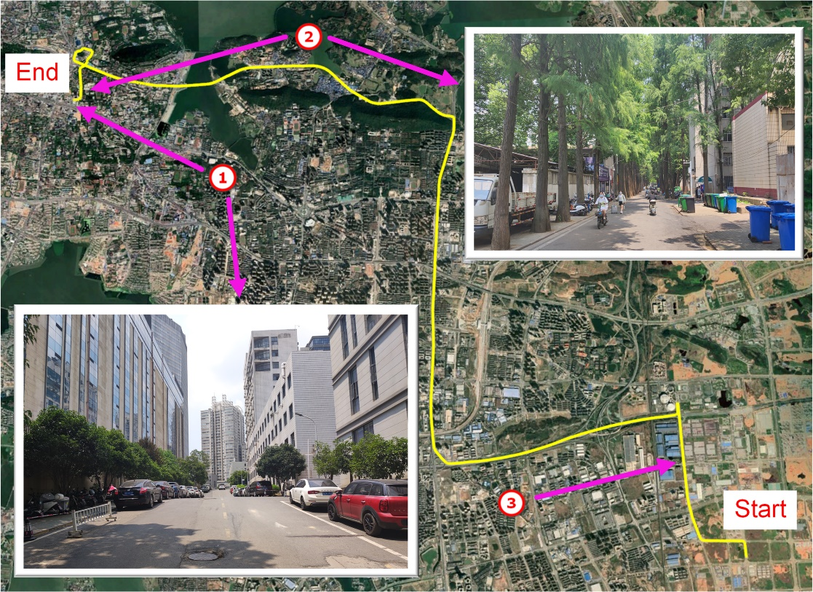

**Fig. 2** Trajectory (yellow) of the vehicle in KPL dataset. The markers represent the road that is heavily occluded by buildings next to the Xinghu Experimental Building of Wuhan University, marker indicates a dense tree-shade road on the campus, and denotes an open-sky road intersection

The smoothed RTK solution from the NovAtel Waypoint 8.9 software package is used as the reference. The format is as follows:

% GPS week number, second of the week, latitude, longitude, ellipsoidal height, north velocity, east velocity, up velocity, north STD, east STD, height STD, north velocity STD, east velocity STD, height velocity STD, quality number

For the reference positioning results, the GNSS quality number output from the software indicates their quality, and their description can be found in page 77 of NovAtel Waypoint Software 8.90 User Manual v10. **Fig. 3** shows the time series of GNSS quality number for the KPL Dateset. It can reflect the approximate accuracy of the reference value.



**Fig. 3** Time series of GNSS quality number from NovAtel Waypoint Software of KPL Dataset

In (Li, 2023), we present the statistics of single-frequency (GPS: L1, BDS: B1I, GLONASS: G1, Galileo: E1) SPP and RP localization results for each scenario, therefore, the description will not be repeated here. If POSGO is installed correctly, the following fig can be obtained using the drawing script. **Fig. 4** and **Fig. 5** is LSQ and GOLD for SPP, respectively. **Fig. 6** and **Fig. 7** is EKF and GOLD for RP, respectively. Several other scenarios can be verified by yourself.

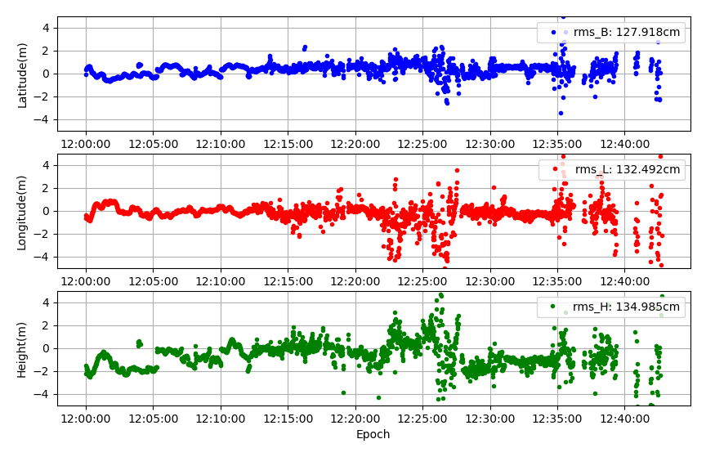

**Fig. 4** Time series of positioning errors of KPL dataset in the north (N, blue), east (E, red), and up (U, green) components of the LSQ for SPP

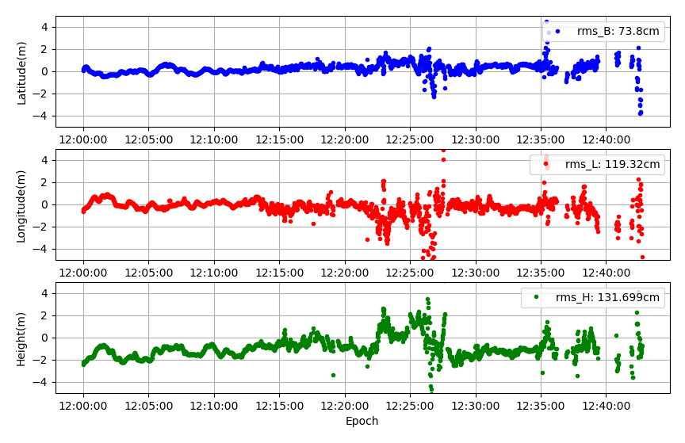

**Fig. 5** Time series of positioning errors of KPL dataset in the north (N, blue), east (E, red), and up (U, green) components of the GOLD for SPP

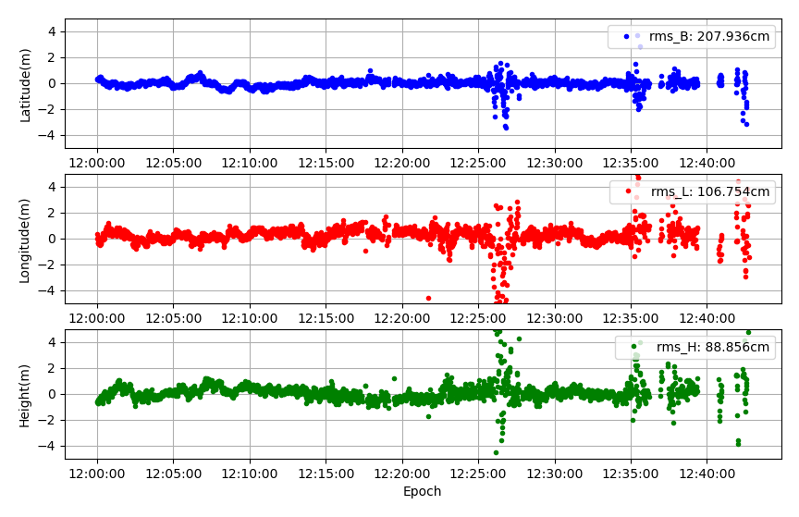

**Fig. 6** Time series of positioning errors of KPL dataset in the north (N, blue), east (E, red), and up (U, green) components of the EKF for RP

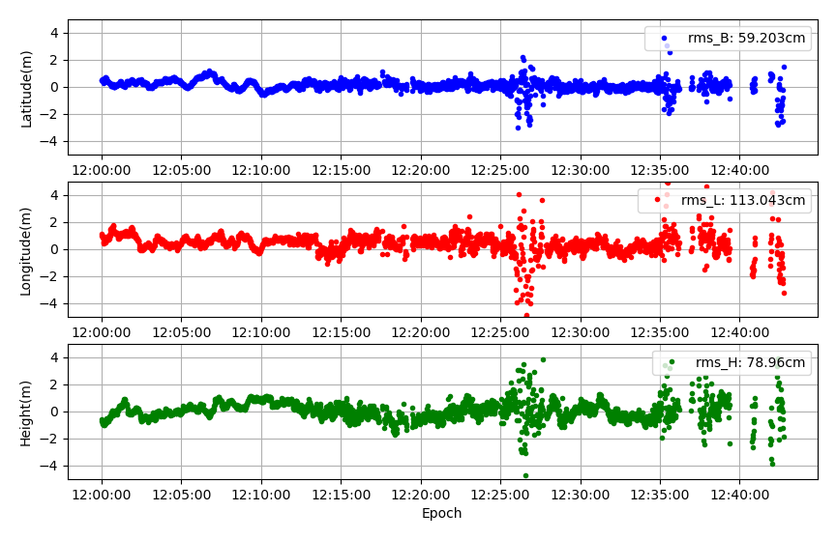

**Fig. 7** Time series of positioning errors of KPL dataset in the north (N, blue), east (E, red), and up (U, green) components of the GOLD sfor RP

## Huawei P40 Dataset

This dateset is a kinematic vehicle experiment in an urban area of Wuhan city was performed during 3:35~4:20 (UTC) on Day of Year (DOY) 183, 2022. The vehicle went to the vicinity of Wuhan University from the FoZuLing area. **Fig. 8** shows the vehicle trajectory. Huawei P40 mobile phone was used as rover, and base station use Geoelectron NET10 Plus receivers. The P40 is mounted on the roof and close to Leador A15 GNSS/INS integrated navigation system. The installation position of the equipment is shown in **Fig. 9**. The smooth solution of A15 solved by GINS is used as the reference. The format is as follows:

% GPS week number, second of the week, latitude, longitude, ellipsoidal height, north velocity, east velocity, up velocity, roll angle, pitch angle, heading angle

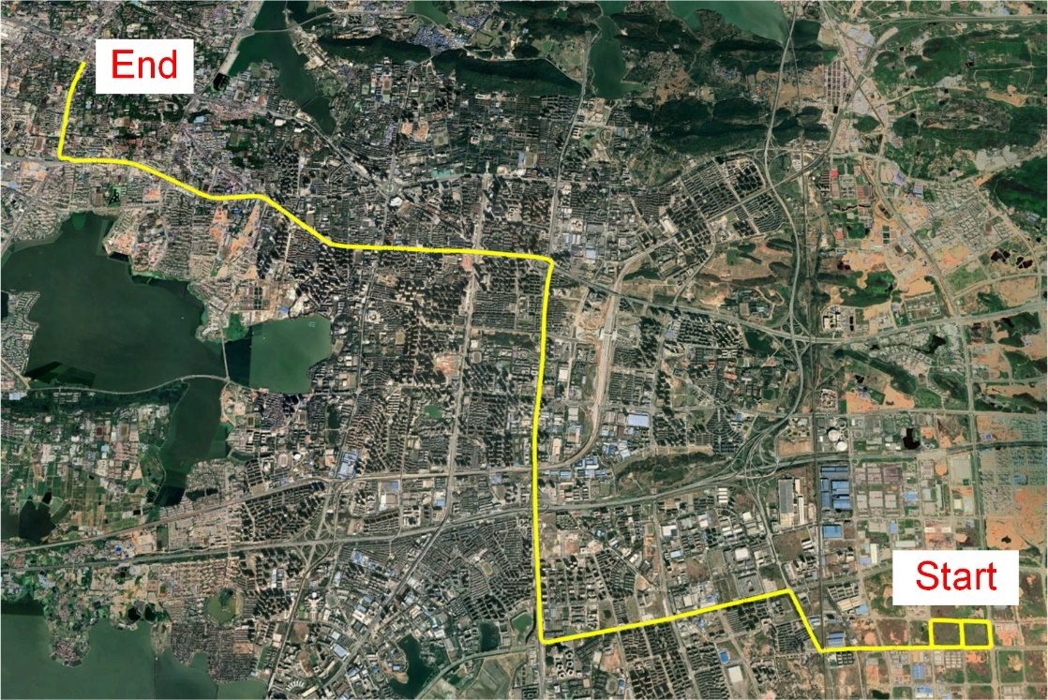

**Fig. 8** Trajectory (yellow) of the vehicle in P40 dataset.

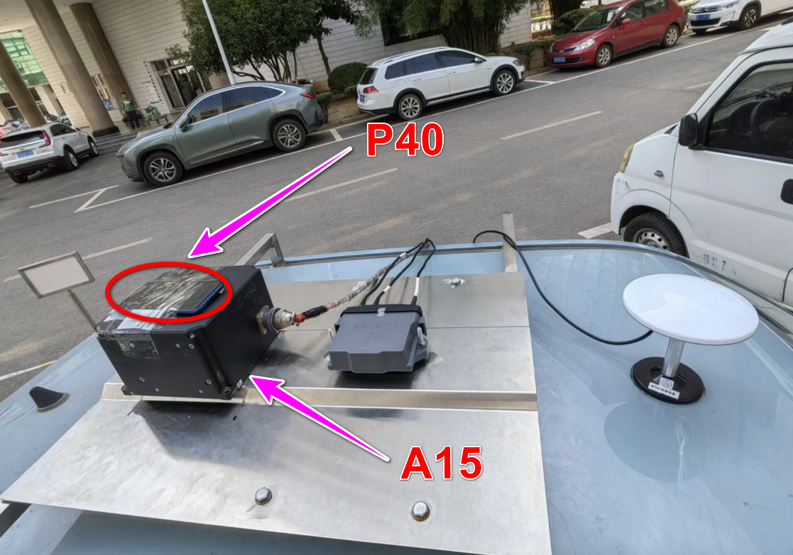

**Fig. 9** Installation position of the equipment.

LSQ and GO solution of SPP are shown in **Fig. 10** and **Fig. 11**, respectively. EKF and GO solution of RP are shown in **Fig. 12** and **Fig. 13**, respectively. For more detailed configuration information, please check the related configuration files.

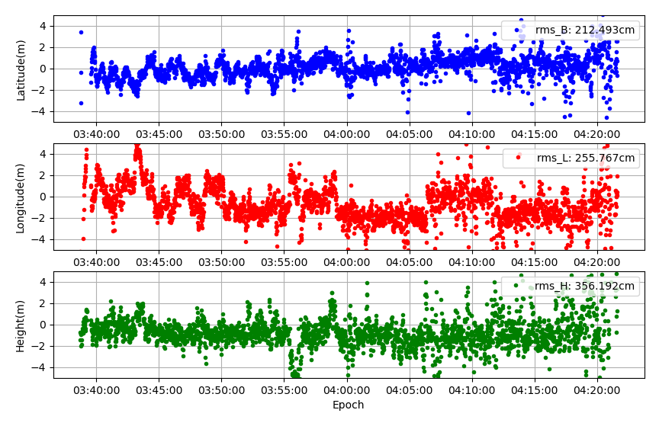

**Fig. 10** Time series of positioning errors of P40 dataset in the north (N, blue), east (E, red), and up (U, green) components of the LSQ for SPP

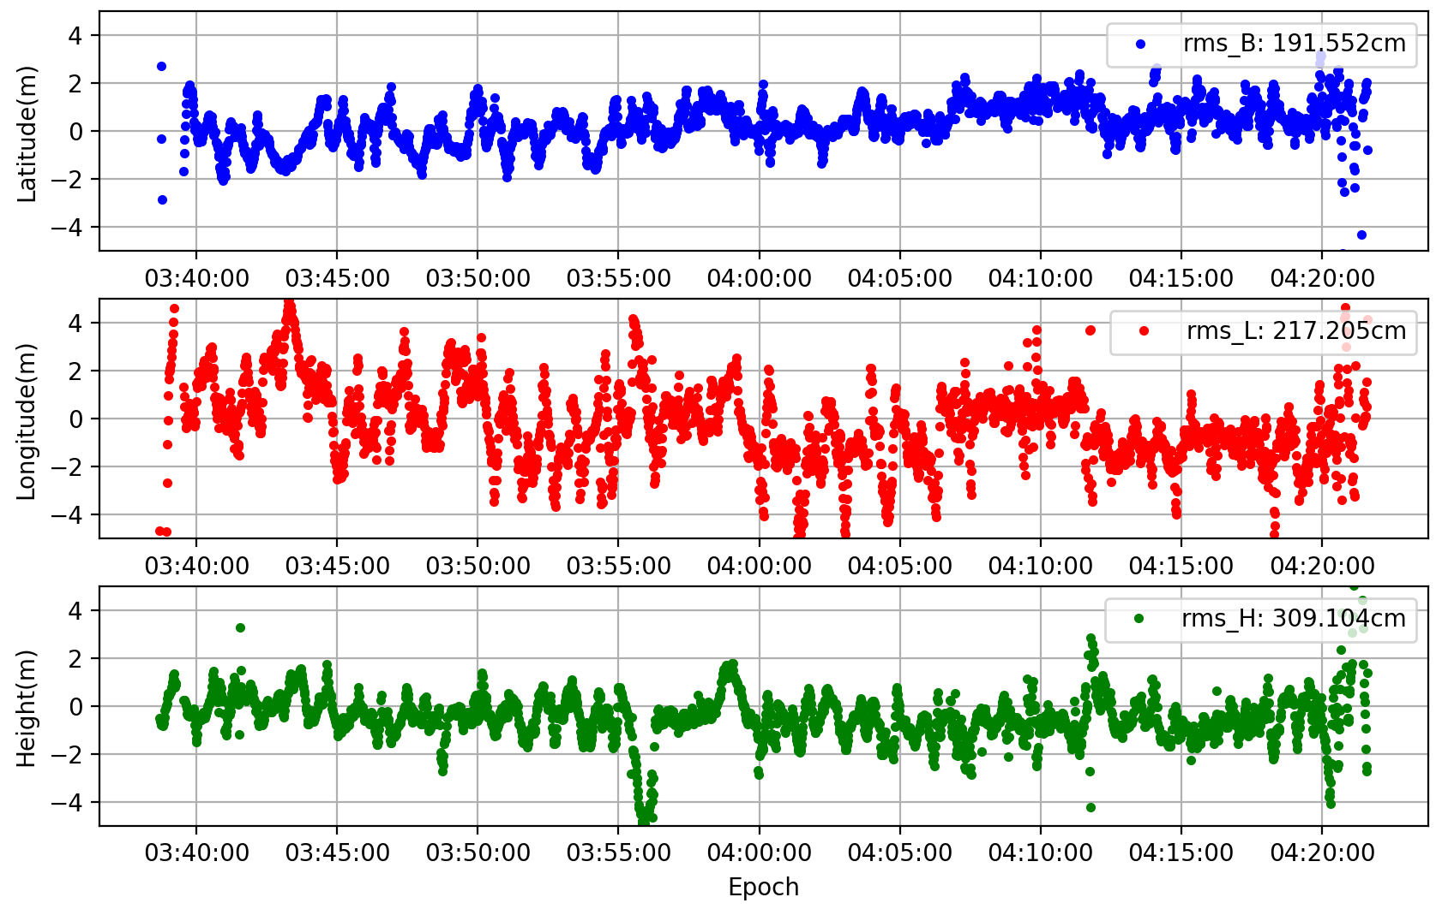

**Fig. 11** Time series of positioning errors of P40 dataset in the north (N, blue), east (E, red), and up (U, green) components of the GO for SPP

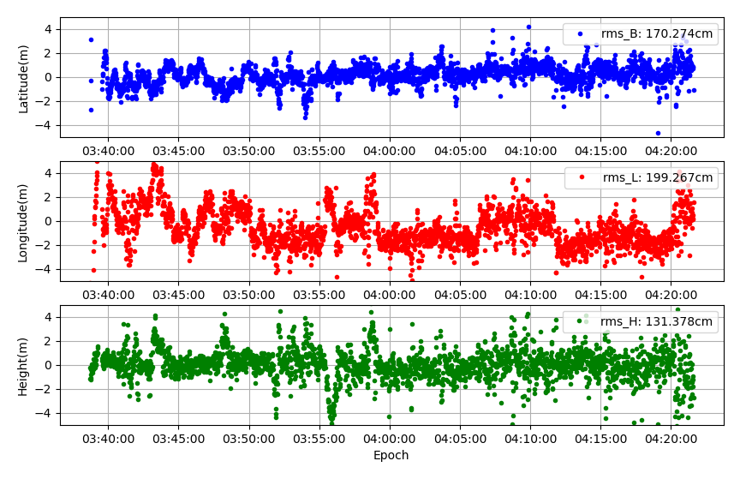

**Fig. 12** Time series of positioning errors of P40 dataset in the north (N, blue), east (E, red), and up (U, green) components of the EKF for RP

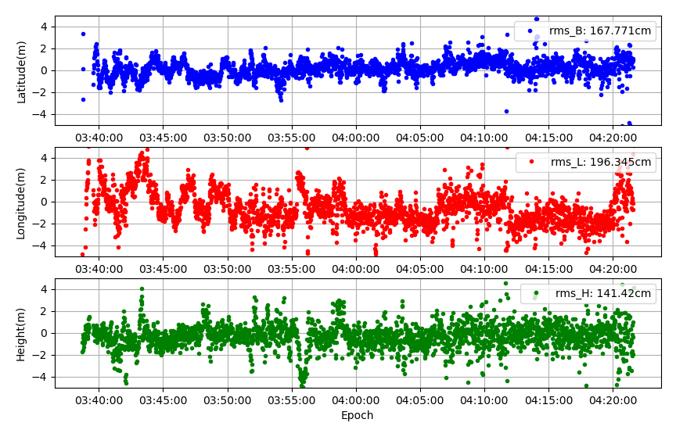

**Fig. 13** Time series of positioning errors of P40 dataset in the north (N, blue), east (E, red), and up (U, green) components of the GO for RP

## Huawei Mate20 Dataset

This dataset is a static experiment in an urban canyon near Wuhan University during 6:35~6:50 (UTC) on Day of Year (DOY) 266, 2021. Huawei Mate20 mobile phone was used as data collection device, and the reference solution is obtained from RTK(≤3cm). As shown in the **Fig. 14** and **Fig. 15**, the surrounding trees and tall buildings, etc., seriously block the GNSS signal, which significantly increases the difficulty of position.

We used this dataset to compare the position accuracy of LSQ and GO. LSQ uses the IGG3 quality control algorithm, and GO with a 60 s sliding window length, Cauchy loss function, and Doppler factor. For more detailed configuration information, please check the related configuration files. The results of the two scenarios are shown in **Fig. 16** and **Fig. 17**, respectively. Also, we can see that the position accuracy of GO is better than LSQ.

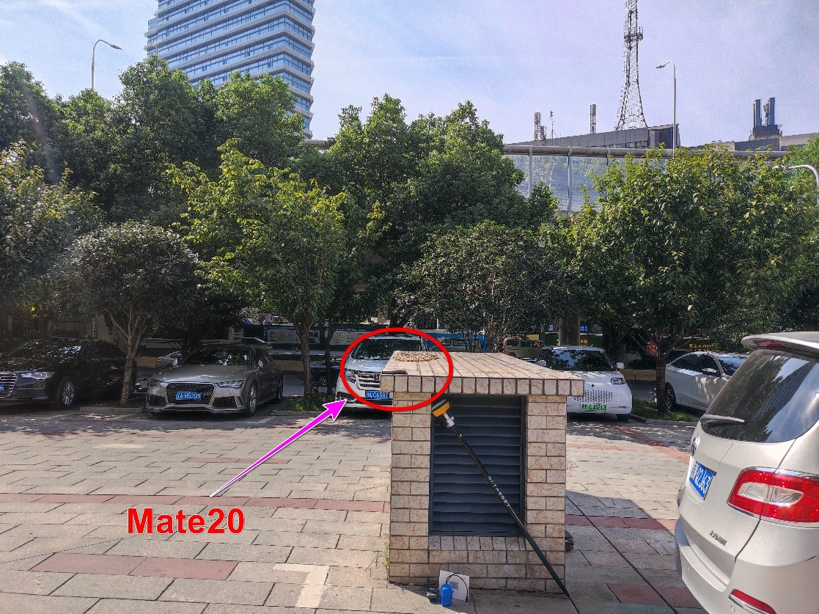

**Fig. 14** Experimental environment (trees shade)

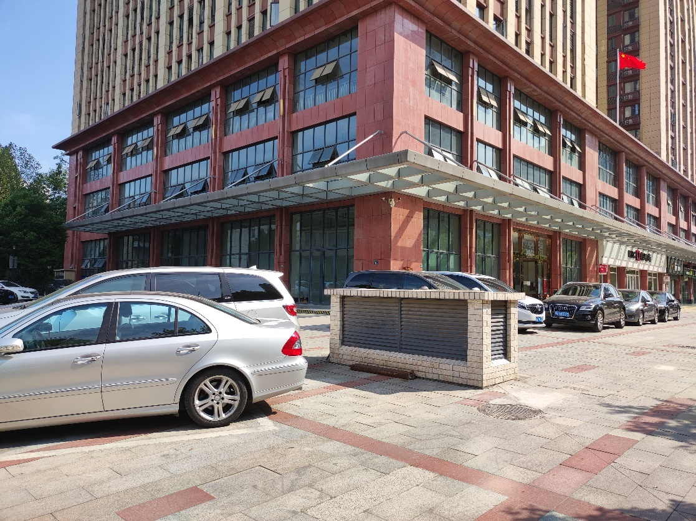

**Fig. 15** Experimental environment (tall buildings)

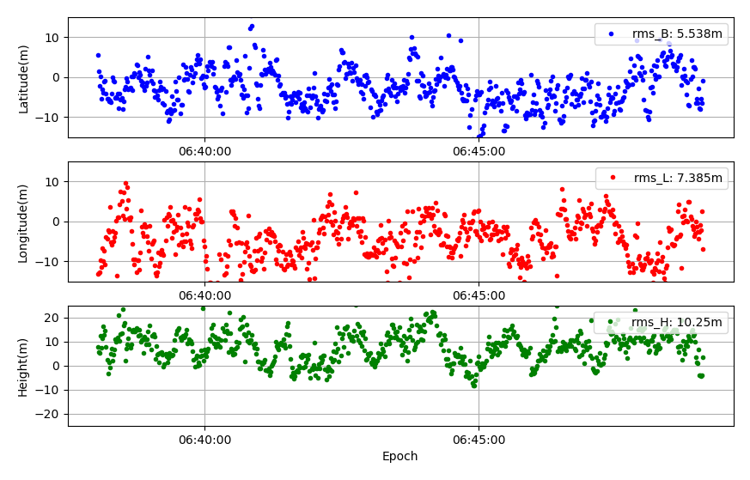

**Fig. 16** Time series of positioning errors of Mate20 dataset in the north (N, blue), east (E, red), and up (U, green) components of the LSQ for SPP

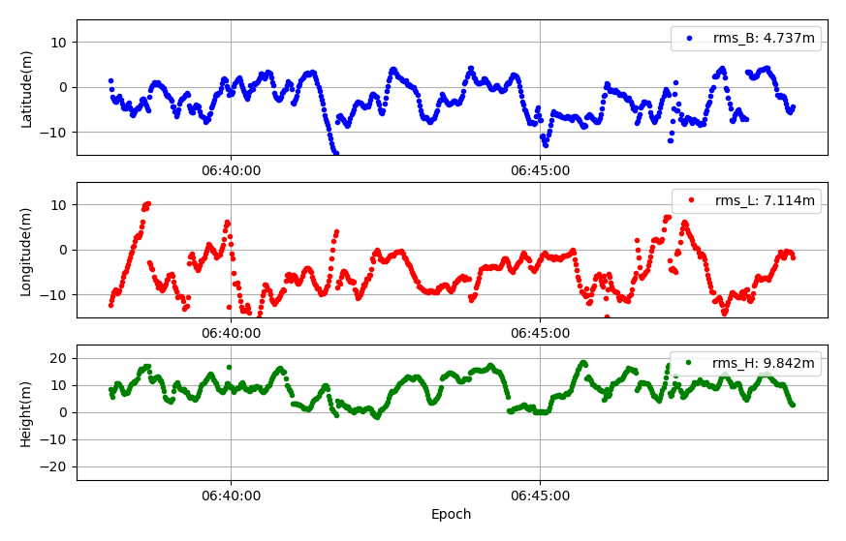

**Fig. 17** Time series of positioning errors of Mate20 dataset in the north (N, blue), east (E, red), and up (U, green) components of the GO for SPP

# Mathematical Model

## Graph optimization

Graph optimization is a method used to express the optimization problem in graphs. The nodes in the graph can represent objects that need to be optimized, and the edges can be used to represent the constraint relationships between nodes. A typical graph to be optimized can be represented by Fig. 18. Then, the solution of the problem can be regarded as finding the minimum of an error function $F\left(P\right)$ of this form:

$F\left(P\right)=\sum{e{\left(p_{i},p_{j},z_{i,j}\right)}^{T}Ω_{ij}e\left(p_{i},p_{j},z_{i,j}\right)}$ (1)

$P^{*}=\underset{P}{argmin}{F\left(P\right)}$ (2)

where $P=\left(p_{1}^{T},p_{2}^{T},…p_{n}^{T}\right)$ is a vector of parameters, $P^{*}$ represents its optimal value, $p_{i}$ represents a generic parameter set, and $z_{i,j}$ and $Ω_{ij}$ denote the mean and information matrix of the constraints related to $p_{i}$ and $p_{j}$, respectively. $e\left(p_{i},p_{j},z_{i,j}\right)$ is the error function for measuring the degree to which the parameter sets $p_{i}$ and $p_{j}$ satisfies the constraint $z_{i,j}$. The function $\underset{P}{argmin}{F\left(P\right)}$ returns the argument $P$ that minimizes the objective function $F\left(P\right).$



**Fig. 18** A typical graph to be optimized. The blue circles denote the states to be optimized in the slide window. The green circles denote the constraint factors.

The numerical solution of Equation (2) can be obtained by using the popular Gauss‒Newton or Levenberg–Marquart algorithm (Nocedal and Wright 2006). Moreover, to reduce the burden of calculation, the sliding window is typically used to prevent the infinite growth of the graph (Dellaert and Kaess 2017).

## SPP using graph optimization

The graph structure of the SPP algorithm is shown in Fig. 19. The states of the rover can be expressed as

$X=\left[x_{1},x_{2},…x_{n}\right]$ (3)

$x_{i}=\left[p_{i},{dt}_{r}^{G},{ISB}_{G}^{C},{ISB}_{G}^{R},{ISB}_{G}^{E}\right]$ (4)

where $X$ is a set of states in the slide window with a length of $n$ epochs. $x_{i}$ denotes the states of the rover at epoch $i$, which usually contains the position ($p_{i}$), receiver clock error of GPS (${dt}_{r}^{G}$), and intersystem biases between GPS and BDS (${ISB}_{G}^{C}$), GLONASS (${ISB}_{G}^{E}$), Galileo (${ISB}_{G}^{E}$), and more.



**Fig. 19** The graph structure of SPP in POSGO software. The blue circles denote the sets of rover states in the slide window. The green circles indicate the pseudorange factors, and the red rectangles represent the Doppler velocity factors.

In summary, there are two factors in the SPP graph structure: the pseudorange factor and the Doppler velocity factor.

1. **Pseudorange factor**

In our software, the pseudorange observation can be used directly in optimization. The error function for the pseudorange factor $e_{P,i}^{s}$ can be expressed as

${\left\|e_{P,i}^{s}\right\|}_{∑_{P,i}^{s}}^{2}={\left\|{Psr}_{i}^{s}-H_{i}^{s}\left(x_{i}\right)\right\|}_{∑_{P,i}^{s}}^{2}$ (5)

With

${Psr}_{i}^{s}=r_{i}^{s}+c\left({dt}_{r}-{dt}^{s}\right)+I_{r}^{s}+T_{r}^{s}+ε_{r}^{s}$ (6)

$H_{i}^{s}\left(x_{i}\right)=\left\|p_{i}^{s}-p_{i}\right\|$ (7)

where ${Psr}_{i}^{s}$ indicates the code observation model of satellite $s$ at epoch $i$ and $r_{i}^{s}$ is the geometric range between the satellite $s$ and the receiver. $I_{r}^{s}$ and $T_{r}^{s}$ indicate the ionospheric delay and tropospheric delay, respectively. $ε_{r}^{s}$ represent the measurement error and multipath, etc. $H_{i}^{s}\left(x_{i}\right)$ is the function of the distance between the satellite and receiver. $p_{i}^{s}$ and $p_{i}$ represent the positions of the satellite and rover at $i$ epoch, respectively. $∑_{i}^{s}$ denotes the covariance matrix and can be determined based on elevation or signal-to-noise ratio (SNR).

1. **Doppler velocity factor**

Each state in the slide window is connected with the Doppler velocity factor. The error function of the Doppler velocity factor $e_{i+1}^{Dop}$ can be expressed as

${\left\|e_{i+1}^{Dop}\right\|}_{∑_{i+1}^{Dop}}^{2}={\left\|{Vel}_{i+1}^{Dop}-H_{i+1}^{Vel}\left(x_{i+1},x_{i}\right)\right\|}_{∑_{i+1}^{Dop}}^{2}$ (8)

with

$H_{i+1}^{Vel}\left(x_{i+1},x_{i}\right)=\left[\begin{matrix}\left(p_{i+1,x}-p_{i,x}\right)/△t \\ \left(p_{i+1,y}-p_{i,y}\right)/△t \\ \left(p_{i+1,z}-p_{i,z}\right)/△t\end{matrix}\right]$ (9)

where ${Vel}_{i+1}^{Dop}$ denotes the velocity estimated by Doppler observation. $H_{i+1}^{Vel}\left(x_{i+1},x_{i}\right)$ is the velocity function between states $x_{i}$ and $x_{i+1}$. $p_{i,x}$, $p_{i,y}$, and $p_{i,z}$ represent the position of the rover in the X, Y and Z directions at epoch $i$. $△t$ denotes the time difference between epochs $i$ and $i+1$. The variable $∑_{i+1}^{Dop}$ is the corresponding covariance matrix.

The pseudorange factor for each epoch is connected to the state of that epoch, and each state in the sliding window is connected using the doppler velocity factor. In summary, the objective function for SPP using GO can be expressed as:

$X^{*}=argmin\sum_{i}^{n}{\left({\left\|e_{P,i}^{s}\right\|}_{∑_{P,i}^{s}}^{2}+{\left\|e_{i}^{Dop}\right\|}_{∑_{i}^{Dop}}^{2}\right)}$ (10)

where $n$ is the length of the sliding window. The optimal estimation $X^{*}$ for state set $X$ is obtained by minimizing the objective function.

## RP using graph optimization

The graph structure of RP is shown in Fig. 20. The state of receiver $x_{i}$ in set $X$ is slightly different from that of SPP and can be expressed as follows:

$x_{i}=\left[p_{i}\right]$ (11)

As the receiver clock is eliminated by double difference, only position $p_{i}$ needs to be estimated.



**Fig. 20** The graph structure of RP in POSGO software. The blue circles denote the sets of rover states in the sliding window. The yellow circles represent the reference stations. The green circles denote the double-differenced pseudorange factors, and the red rectangles represent the Doppler velocity factors.

Similar to SPP, there are also two factors in the RP graph structure: the double-differenced pseudorange factor and the Doppler velocity factor. In addition, the reference station coordinates should be introduced as an additional factor and fixed during estimation (Wen and Hsu 2021).

1. **Double-differenced pseudorange factor**

The double-differenced pseudorange observation is used for RP, and its error function $e_{DD,i}^{s}$ in optimization can be expressed as follows:

${\left\|e_{DD,i}^{s}\right\|}_{∑_{DD,i}^{s}}^{2}={\left\|{Psr}_{DD, i}^{s}-H_{DD,i}^{s}\left(x_{i}\right)\right\|}_{∑_{DD,i}^{s}}^{2}$ (12)

With

${Psr}_{DD, i}^{s}=\left({Psr}_{i}^{s}-{Psr}_{b}^{s}\right)-\left({Psr}_{i}^{ref}-{Psr}_{b}^{ref}\right)$ (13)

$H_{DD,i}^{s}\left(x_{i}\right)=\left(\left\|p_{i}^{s}-p_{i}\right\|-\left\|p_{i}^{s}-p_{b}\right\|\right)-\left(\left\|p_{i}^{ref}-p_{i}\right\|-\left\|p_{i}^{ref}-p_{b}\right\|\right)$ (14)

where ${Psr}_{DD,i}^{s}$ denotes the double-differenced pseudorange at epoch $i$. ${Psr}_{b}^{s}$ stands for the $s$ pseudorange received by the base station. ${Psr}_{i}^{ref}$ and ${Psr}_{b}^{ref}$ indicated the reference satellite pseudorange received by rover and base station, respectively. Generally, reference satellite has the highest elevation angle, as it tends to involve the lowest multipath and NLOS error. $H_{DD,i}^{s}\left(x_{i}\right)$ is the function of the double-differenced distance between the satellites and base as well as rover sites. $p_{i}^{ref}$ and $p_{b}$ are the positions of the reference satellite and reference station, respectively. $∑_{DD,i}^{s}$ denotes the corresponding covariance matrix.

1. **Doppler** **velocity factor**

The error function of the Doppler velocity factor in RP is the same as Equation (7), and each state is also connected by Doppler velocity factors.

Therefore, the objective function for RP can be obtained as follows:

$X^{*}=argmin\sum_{i}^{n}{\left({\left\|e_{DD,i}^{s}\right\|}_{∑_{DD,i}^{s}}^{2}+{\left\|e_{i}^{Dop}\right\|}_{∑_{i}^{Dop}}^{2}\right)}$ (15)

The estimated value $X^{*}$ can be estimated by solving the objective function.

## Estimation of Velocity

The velocity ${Vel}_{i+1}^{Dop}$ at each epoch needs to be estimated before constructing the optimization problem, if the sliding window length is greater than 1. After adding the Doppler velocity factor, as it uses all the data in sliding window to estimate the current position, which makes it more resistant to outliers.

The velocity can be estimated by Doppler observation. The rover velocity and clock‐drifts can be estimated the following procedure. For an epoch time, the unknown parameters vector $x$ is defined as:

$x=\left[{Vel}_{i}^{Dop},cd{\dot{t}}_{r}\right]$ (16)

where ${Vel}_{i}^{Dop}$ and $cd{\dot{t}}_{r}$ are the rover velocity in ECEF (m/s) and the clock‐drift (s/s), respectively. The range‐rate measurement vector $y$ can be given as:

$y={\left[-λ_{i}D_{r,i}^{1}, -λ_{i}D_{r,i}^{2},-λ_{i}D_{r,i}^{3},…,-λ_{i}D_{r,i}^{s}\right]}^{T}$ (17)

wheres $D_{r,i}^{1}$ is the $i$ frequency Doppler measurement of the satellite $s$ and $λ_{i}$ is the corresponding wavelength. These measurement equations and its partial derivative matrix are formed as:

$h\left(x\right)=\left[\begin{matrix}r_{r}^{1}+cd{\dot{t}}_{r}-cd{\dot{T}}^{1} \\ r_{r}^{2}+cd{\dot{t}}_{r}-cd{\dot{T}}^{2} \\ \begin{matrix}\begin{matrix}r_{r}^{3}+cd{\dot{t}}_{r}-cd{\dot{T}}^{3} \\ ⋮\end{matrix} \\ r_{r}^{s}+cd{\dot{t}}_{r}-cd{\dot{T}}^{s}\end{matrix}\end{matrix}\right] H=\left[\begin{matrix}-e_{r}^{1T} & 1 \\ -e_{r}^{2T} & 1 \\ \begin{matrix}-e_{r}^{3T} \\ ⋮ \\ -e_{r}^{mT}\end{matrix} & \begin{matrix}1 \\ ⋮ \\ 1\end{matrix}\end{matrix}\right]$ (18)

The range‐rage $r_{r}^{s}$ between the rover and the satellite is derived from:

$r_{r}^{s}=e_{r}^{sT}\left(v^{s}t^{s}-v_{r}\right)+\frac{ω_{e}}{c}\left(v_{y}^{s}x_{r}+y^{s}v_{x,r}-v_{x}^{s}y_{r}-x^{s}v_{y,r}\right)$ (19)

where $v^{s}={\left[v_{x}^{s}, v_{y}^{s},v_{z}^{s}\right]}^{T}$ and $v_{r}={\left[v_{x,r}, v_{y,r},v_{z,r}\right]}^{T}$. $ω_{e}$ indicates the Earth's rotation and $c$ represents the velocity of light in a vacuum. Then we can estimate the velocity and clock‐drift using the least squares algorithm(Takasu and Yasuda 2009).

In addition, the time difference of carrier phase (TDCP) can also be used for velocimetry and it can be controlled by "Velocimetry" in the POSGO configuration file. TDCP reflect s the average velocity between epochs and the accuracy of carrier observations is higher. So higher velocity accuracy can be achieved after correct handling of cycle slips, but it needs to use additional carrier observations. Besides, the Doppler velocity factor will become TDCP velocity factor.

# Acknowledgement

First, we pay tribute to Dr. Tomoji Takasu, the author of RTKLIB software for his selfless open-source spirit and elegant programming. Many functions code of POSGO are modified from the RTKLIB code. The software is also referring to the GraphGNSSLib software of Weisong Wen from Hong Kong Polytechnic University and OB_GINS software of Hailiang Tang from Wuhan University. We also thanks for their open-source spirit.

# Reference

Li Z, Guo J, Zhao Q (2023) POSGO: an open-source software for GNSS pseudorange positioning based on graph optimization.

Dellaert F, Kaess M (2017) Factor Graphs for Robot Perception. Foundations and Trends® in Robotics 6(1–2):1–139. https://doi.org/10.1561/2300000043

Nocedal J, Wright S (2006) Numerical Optimization 2nd Edition. Springer Science & Business Media

Takasu T, Yasuda A (2009) Development of the low-cost RTK-GPS receiver with an open source program package RTKLIB. In: International symposium on GPS/GNSS. International Convention Center Jeju Korea

Wen W, Hsu L-T (2021) Towards Robust GNSS Positioning and Real-time Kinematic Using Factor Graph Optimization. In: 2021 IEEE International Conference on Robotics and Automation (ICRA). IEEE, Xi’an, China, pp 5884–5890